Liberty University
Master of Public Health
HLTH634-B01

Communication Artifact: Topic Selection and Qualifications Brief

Madison Gayle Spurling
ID: L34916045
August 30, 2026

Words: 910

Topic
Expanding access to healthcare is not just an individual’s issue, but a public health issue. I will focus on how these barriers affect vulnerable rural Southerners. Healthy People 2030 has noted that many people face barriers to accessing necessary health care services, which can contribute to poorer health outcomes and widen existing health disparities.¹ Access to health services is an important public health priority because individuals and communities cannot achieve optimal health outcomes when they experience barriers to receiving appropriate and timely healthcare.¹ These barriers can range from limited availability of healthcare providers, transportation issues, financial limitations, and other matters that underserved, vulnerable populations face daily.¹ The organization has discovered that when individuals have access to insurance or when other social barriers are eliminated, it leads to healthier individuals and communities.¹
Personally, I have family who have lived in rural Tennessee their entire lives, and these barriers have led to serious situations, so I wish to learn how to address these needs. I also chose this topic because my professional experience has shown me the importance of connecting individuals with appropriate healthcare resources. As a Care Coordinator at Mercy Community Healthcare, I managed approximately 100 patient referrals each month, all while assessing whether the patient’s personal barriers to accessing healthcare resources were addressed. I can share multiple stories about how I learned to love coordinating and communicating with people in vulnerable states to help them access quality healthcare. One that stands out is an elderly female patient who faced transportation barriers to accessing healthcare resources, so I took the time to map bus routes to healthcare centers so she could receive the care she needed.
Additionally, no matter which topic I chose, my faith guided me. The Parable of the Good Samaritan, friends lowering their paralytic friend to meet Jesus, and even Jesus healing the woman suffering from the bleeding illness demonstrate compassion and a willingness to help heal individuals with the resources and gifts bestowed upon them. I have always been drawn to servitude and to giving people the chance to heal. For me, I believe I can improve healthcare access by removing barriers.

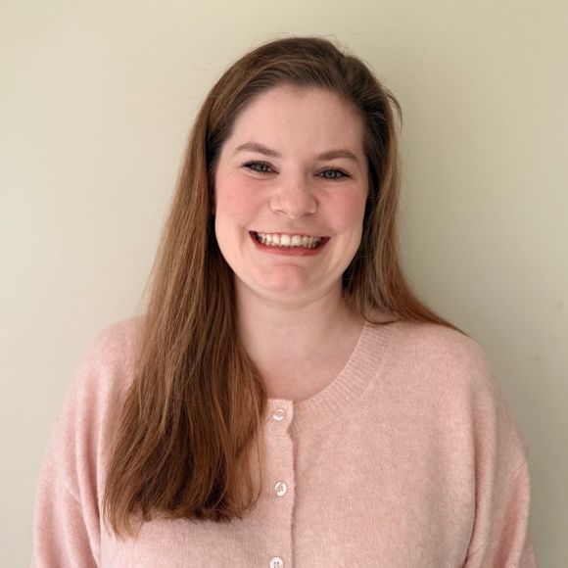
Qualification Brief
I am prepared to address this topic through a combination of academic preparation and work experience. I earned a Bachelor of Science in Biomedical Science from Auburn University, which gave me a solid foundation in critical thinking skills, such as problem-solving, analysis, and organizing information. These skills prepare me to examine the complex factors that can prevent individuals from accessing healthcare, whether they are social or economic. I am currently pursuing a Master of Public Health with a concentration in Community Health Promotion at Liberty University. My coursework covers public health administration, research methods, health program planning, social and behavioral theory, and community health, and has equipped me to identify health disparities and develop evidence-based strategies to improve access to care. Additionally, I have learned how to understand the factors that influence health behaviors in vulnerable communities.
My professional experiences have allowed me to apply these skills in multiple healthcare settings. At a Federally Qualified Healthcare Center, I developed partnerships with community organizations to ensure patients could access needed healthcare services. My time there showed me that collaboration improved communication in addressing an individual’s barriers. In my current role as a referral screening specialist with DCI Donor Services, I manage cases in more a faster-paced environment. This experience has strengthened my ability to prioritize information and the needs of patients or healthcare systems so I can respond effectively.
Furthermore, volunteering has highlighted my natural skills. As an Inpatient Visitor Ambassador, I further developed my ability to communicate with patients and healthcare personnel. These interactions prepared me to approach access to health services from both a patient-centered and public health perspective. These opportunities, both academically and professionally, also show that I can put others’ needs above my own. Paul even instructs the church to “not [look] to your own interests but each of you to the interests of the others”.² This purpose can be accomplished by identifying a person’s needs, effective communication, coordination and teamwork, and connecting people with personalized resources through actively listening. These skills support my goal as a public health professional to reduce barriers to care and promote healthier communities.

Reflection
I believe God has instilled in me a passion to advocate for those whose voices are often unheard, and this calling gives me an important perspective on addressing access to health services. Being “the salt of the earth” and “the light of the world” means serving others by recognizing their needs and using our gifts to make a positive difference in their lives.³ These sayings are popular in even the secular culture, which can be seen in healthcare. However, public health offers an opportunity to show that improving health is not limited to providing medical treatment. Sometimes, improving health begins with listening to a geriatric patient tell you how to cook a proper pot roast, or understanding their circumstances without judgment. One particularly meaningful experience involved helping a man experiencing homelessness access a medication assistance program. By noticing a shirt that read “Roll Tide” and jokingly saying that helping him would be difficult because I was an Auburn fan, I changed his demeanor. That connection opened the door to connecting him with the health resources he needed. Building trust and appreciating the person behind the need leads to the health-focused change I wish to see while I work in the public health field.
References

- Office of Disease Prevention and Health Promotion. Access to health services. Healthy People 2030. Accessed August 29, 2026. https://odphp.health.gov/healthypeople/priority-areas/social-determinants-health/literature-summaries/access-health-services.

- Philippians 2:4 (New International Version).

- Matthew 5:13-16 (New International Version).

